Practicum Case | 
COMP7116 | COMP7116001 | COMP7116016 | MATH6168 | MATH6168016
Computer Vision
Computer Science | O211-COMP7116-TD01-04
Valid on Odd Semester 2020/2021 | Revision 00

Learning Outcomes
- Various computational principles and standard image processing operators in computer vision
- The local features with their detectors and descriptors in computer vision
- Various features to find correspondence between images and perform recognition in computer vision
- Various image recognition system in computer vision

Topics
- Session 4 – Edge Detection

Subtopics
- Canny
- Sobel
- Laplace
Edge Detection
Edge detection is one of the fundamental operations when we perform image processing. It helps us reduce the amount of data (pixels) to process and maintains the structural aspect of the image. We're going to look into three commonly used edge detection algorithm. The gradient-based edge detector (Sobel) and the based edge detector Laplacian. Laplacian is a 2nd order derivative, so it is extremely sensitive to noise. And a Canny edge detector, which is probably the most commonly used for edge detection. The Canny edge detector is an edge detection operator that uses a multi-stage algorithm to detect a wide range of edges in images.

Before we start, make sure to install and import python libraries bellow
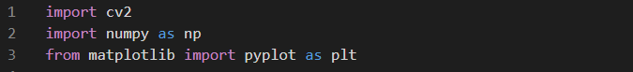
Figure 1. Importing libraries
In this course we will need opencv to do the edge detection, numpy for the ndarray, and matplotlib for the plotting.
- Change the color space
There are more than 150 color-space conversion methods available in OpenCV. But in this course, we will only use BGR to Gray. To do so, we can look at the bellow example.
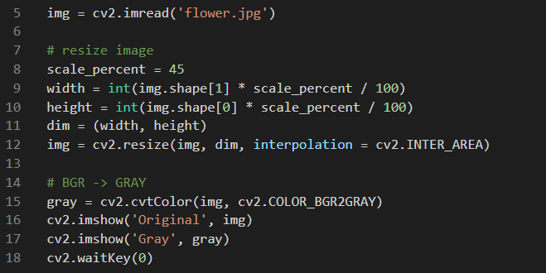
Figure 2. Resizing and changing the color space
As we can see from the above code, we can also use opencv to change the color space of our image. And in the above example we resized the image before changed the color space, because the image we use in this example is too big. Remember, resizing the image does not correlate with changing the color space. So, resizing the image is optional.
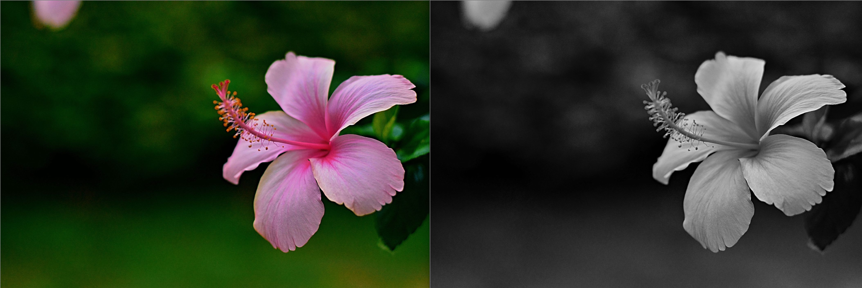
Figure 3. Before and after the color space changed
- Laplacian edge detector
Laplacian is somewhat different from the other methods we have. Unlike the Sobel and Canny edge detectors, the Laplacian edge detector uses only one kernel. It calculates second-order derivatives in a single pass. Because these masks are approximating a second derivative measurement on the image, they are very sensitive to noise. To correct this problem, we often use the Gaussian smoothed we have learned from the “Image Processing” course, before applying the Laplacian filter.
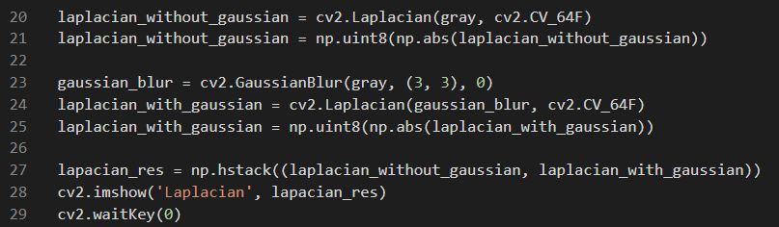
Figure 4. Implementing a Laplacian edge detector
As we can see from the above code, we are using “.Laplacian()” method with 2 arguments. The first argument is the source image, and the second argument is the output data type. For the second argument, we are using the CV_64F which is the same as CV_64FC1. In CV_64FC, the “Cx” part shows the number of channels in an image. Remember, that grayscale image has only 1 channel. So if we just need a single channeled 2d matrix, we can just use CV_64F. And in this case, CV_64F is better than CV_8U because the Black-to-White transition is taken as a positive slope while White-to-Black transition is taken as a negative slope. So when you convert data to np.uint8, all negative slopes are made zero. In simple words, we will miss that edge. The best way to deal with this problem is to keep the output datatype to some higher forms, like cv2.CV_16S, cv2.CV_64F etc, take its absolute value and then convert back to cv2.CV_8U just like what we did in the above code.
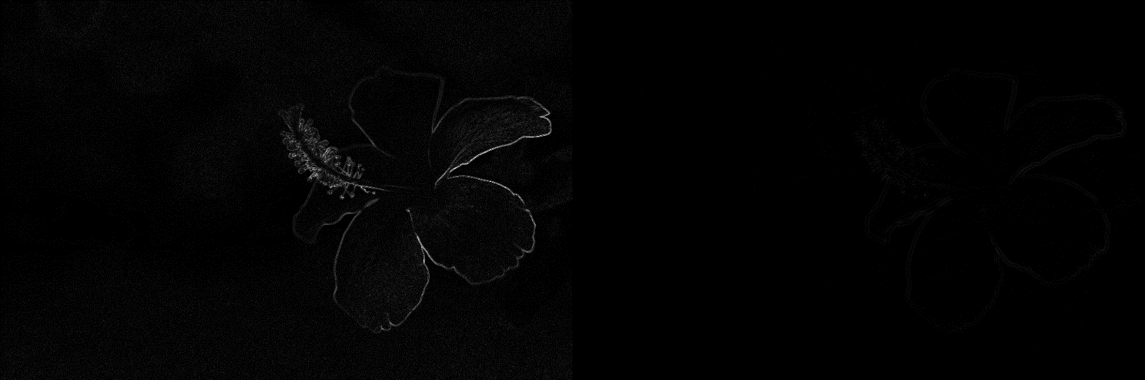
Figure 5. Laplacian without and with gaussian smoothed
- Sobel edge detector
Sobel is one of the most commonly used edge detectors. It is based on convolving the image with a small, separable, and integer valued filter in a horizontal and vertical direction and is therefore relatively inexpensive in terms of computations. The Sobel edge enhancement filter has the advantage of providing differentiating and smoothing concurrently.
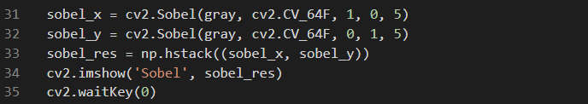
Figure 6. Implementing a Sobel edge detector
In the above code, we are using “.Sobel()” method with 5 arguments. The first 2 arguments are the same as the “.Laplacian()” method we used earlier. The first argument is the image source, and the second is the output data type. The third argument is the x-derivative order or we can say dx. Ant the fourth argument is the y-derivative order or so-called dy. The last argument we are used is the ksize which in this case represents the size of the extended Sobel kernel, it must be 1, 3, 5, or 7.
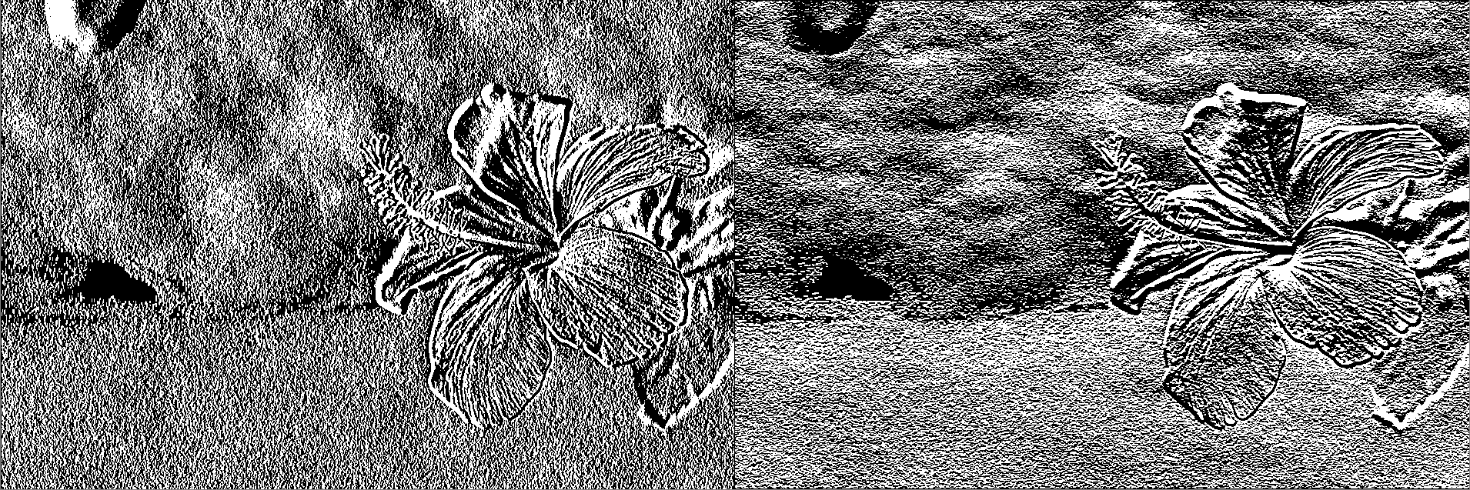
Figure 7. Result of Sobel x and Sobel y
- Canny edge detector
The canny edge detector is probably the most commonly used and most effective method because it’s a much more complex edge detecting method than the ones described above. The Process of the Canny edge detection algorithm can be broken down to 5 different steps:
- Apply Gaussian filter to smooth the image to remove the noise
- Find the intensity gradients of the image
- Apply non-maximum suppression to get rid of spurious response to edge detection
- Apply double threshold to determine potential edges
- Track edge by hysteresis: Finalize the detection of edges by suppressing all the other edges that are weak and not connected to strong edges
Those steps mentioned above have already exists in “.Canny()” method from opencv
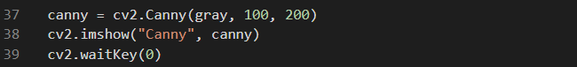
Figure 8. Implementing a canny edge detector
The “.Canny()” method finds edges in the input image and marks them in the output map edges using the Canny algorithm. The smallest value between threshold1 and threshold2 is used for edge linking. The largest value is used to find initial segments of strong edges. The second and third argument in the method represents the dual-threshold we are using. There are some theories to determine the dual-threshold values. To resolve the challenges where it is hard to determine the dual-threshold value empirically, Otsu's method can be used on the non-maximum suppressed gradient magnitude image to generate a high threshold. The low threshold is typically set to 1/2 of the high threshold in this case. Since the gradient magnitude image is continuous-valued without a well-defined maximum, Otsu's method has to be adapted to use value/count pairs instead of a complete histogram.
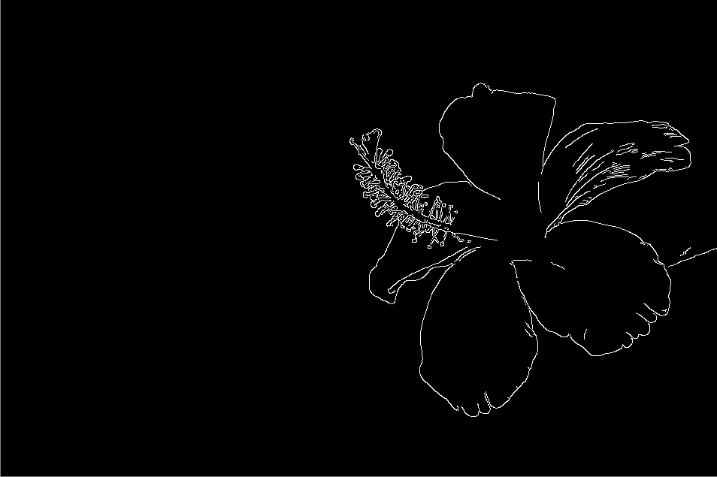
Figure 9. Result of the Canny edge detector
The conclusion is, there is no absolute best edge detector we can use for every image. We must determine which method is the best for our images. And many other things need to be considered, such as speed and performance. So, we cannot always depend only on one of the methods above.
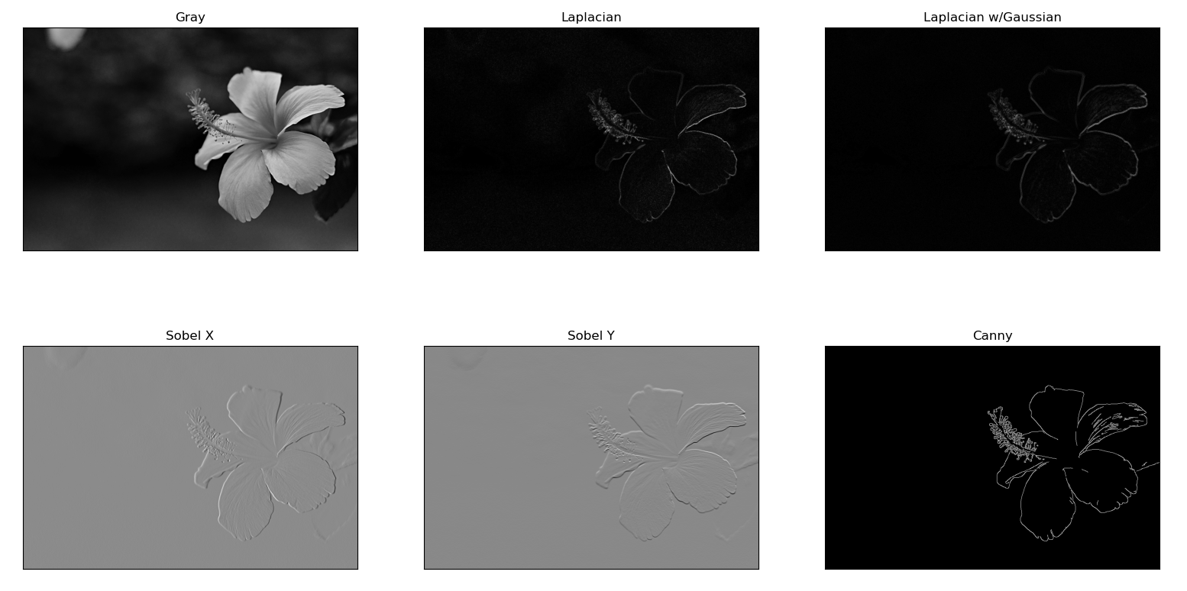
Figure 10. Edge detector results

References:
https://www.countryliving.com/gardening/g3280/flower-pictures/

